
Dear {{Client Name}},
We hope this message finds you well. At Yom International, we take pride in being at the forefront of the fragrance industry, specializing in crafting premium luxury products that not only delight the senses but also promote holistic well-being.
We are excited to introduce you to our exclusive range of products, meticulously crafted with 100% natural ingredients. Our offerings include:
 | 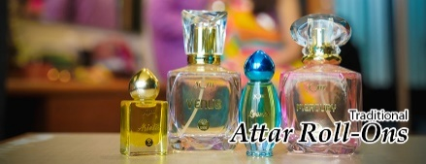 | 
Alcohol-free and color-free, designed to leave a lasting impression… | Capturing the essence of tradition with a modern twist… | A fusion of sophistication and convenience, perfect for those on the go…
But that’s just the beginning. We’re particularly thrilled to present our YOMAROMA Bath Salts, where luxury meets rejuvenation. Inspired by the ancient elements of "Panchtatva," these bath salts offer an unparalleled bathing experience, designed to relax the mind, body, and soul.
Why YOMAROMA Bath Salts?
Stress Relief: Melt away the tensions of the day.
Sound Sleep: Drift into peaceful slumber and wake up refreshed.
Aromatherapy: Experience the therapeutic power of essential oils.
Epsom Salt Benefits: Soothe sore muscles and promote relaxation.
Our variants, including Caeli, Rano, Vyoma, Ignis, and Yomaa, each offer unique blends of essential oils tailored to enhance well-being. Elevate your customer experience by incorporating our luxurious bath salts, guaranteed to leave a lasting impression.
We invite you to explore our full range of products and see how Yom International can enhance your offerings. Click the link below to discover more:
Explore Our Product Catalogue
We would love to discuss how we can tailor our products to meet your specific needs and preferences. Please feel free to reach out to us at your convenience.
Best Regards,
Team Yom

Yom International
Your Own Mantra

