MAIN CATEGORY PAGE (Collections)
Page layout is fine, but what we need is to display the content from our metafields that are already created.
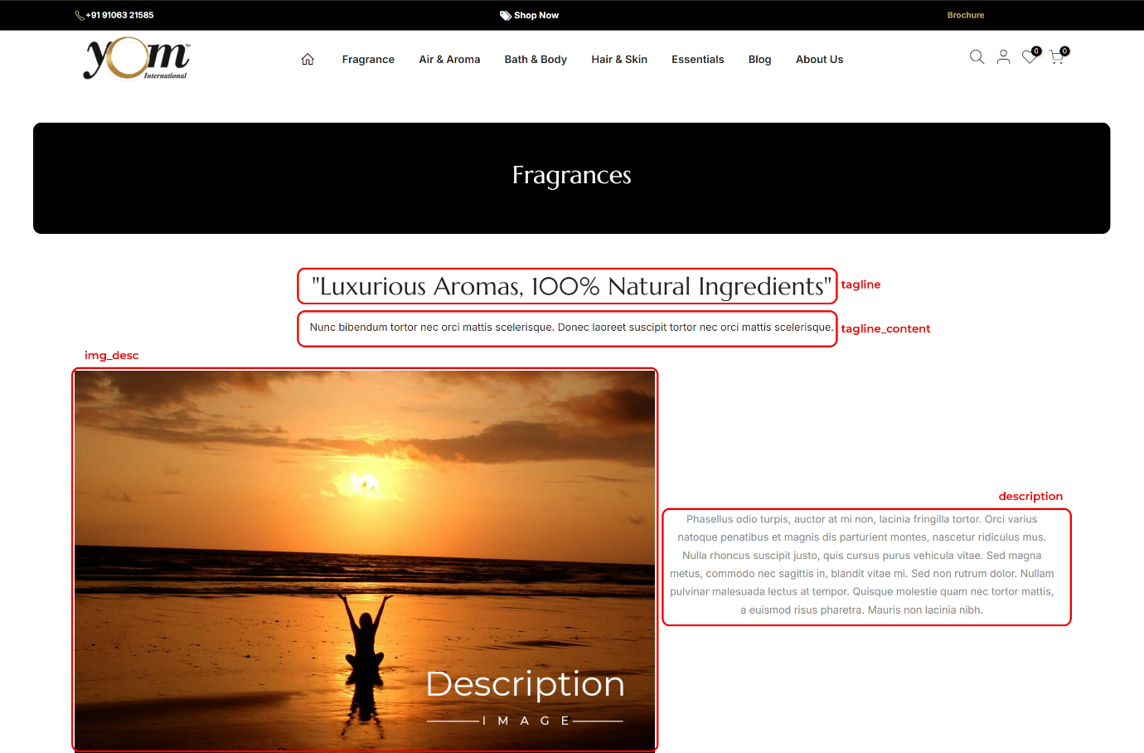
This is the preview of the fields that we already have and we will be uploading all the related images and content for each MAIN CATEGORY in this metafields.
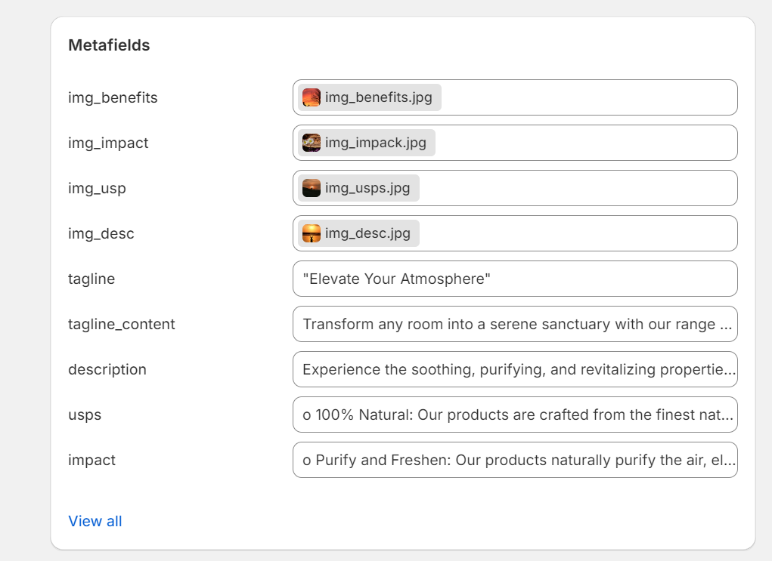

SUB-CATEGORY PAGE (Collections)
Same as in the Main Category we need content to be displayed from our pre-defined metafields.

INDIVIDUAL PRODUCT PAGE
For product page we asked for TABS that will display details about the product below the images, those tabs still does not show the content from the metafields.
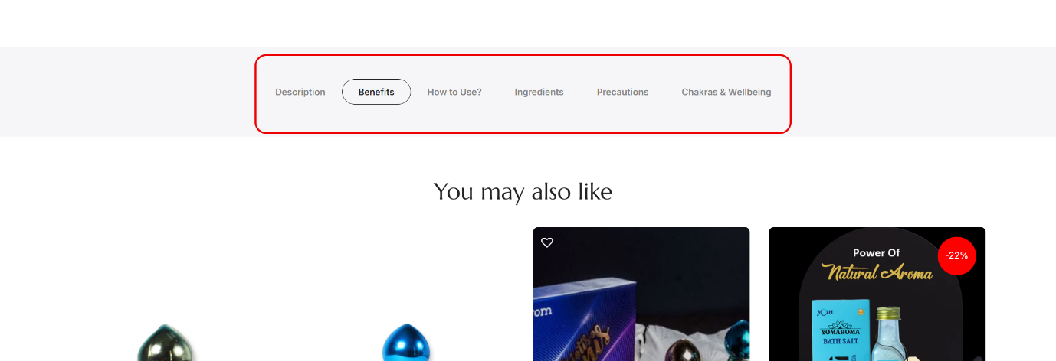
We have all the content for the tabs already in place, we need to display the below showed content to respective tabs.
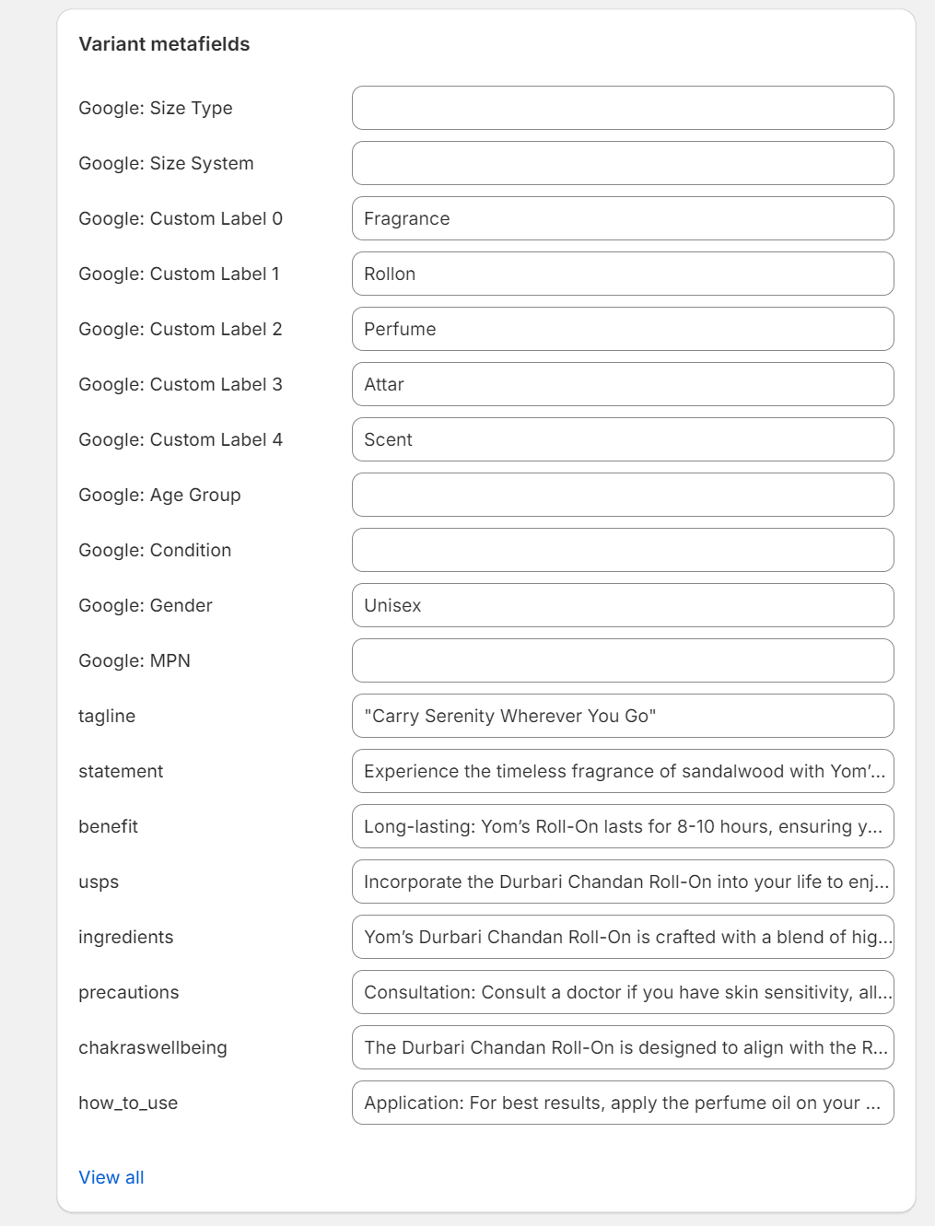

EVENT PAGE
We need an additional page for displaying our UPCOMING and PAST events. It would be similar to blogs, so we will need proper entry page where we can add them by selecting UPCOMING or PAST and provide content and image for each event. This Item should be added to the MAIN MENU along with the BLOG.

GIFT HAMPERS
We already have some Hampers ready but those are non-customizable, I mean it is BUY 2 GET 1 FREE. We would like to add some template like Hampers, which could be easily customized by us, as per our requirements. Type of Hampers we are looking for are as follow:
- Buy 1 Get 1 Free
- Buy 1 at { X% } Off
- Combo of 2 { X% } Off
- Combo of 5 { X% } Off
We want template such that we could change the product as well as the discount percentage (%) as per our requirements.

MENU
You need to update the Menu with EVENTS link. Also once need to check out the menu on Mobile on my mobile it is showing different.
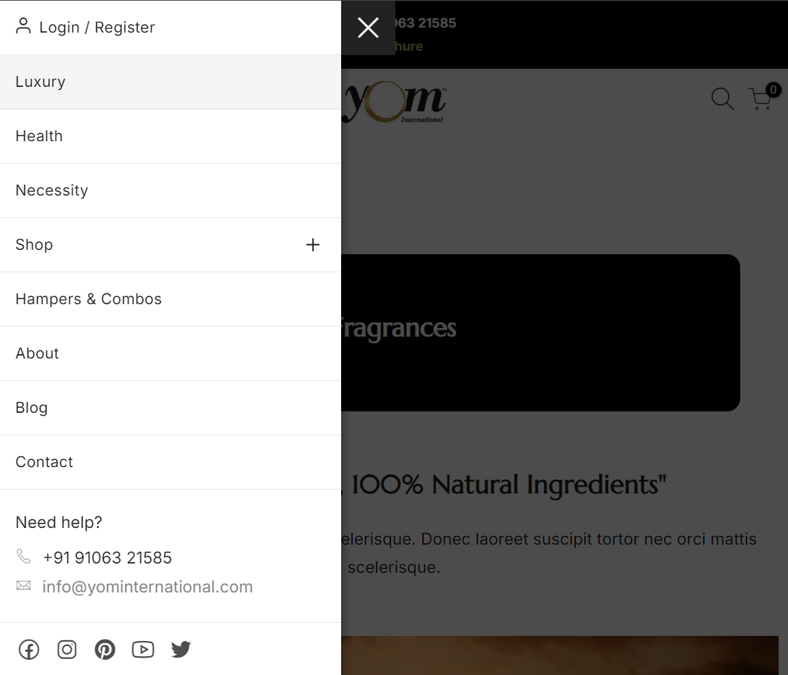

NOTE: I have attached 2 PDF files for your reference, to check out what type of metafields are already created. Our goal is to display information from the metafields, so whenever we need to change the content, we can just update the values of metafields and that would be updated on the site.

